**Introduction:**

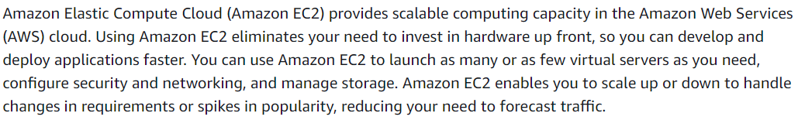

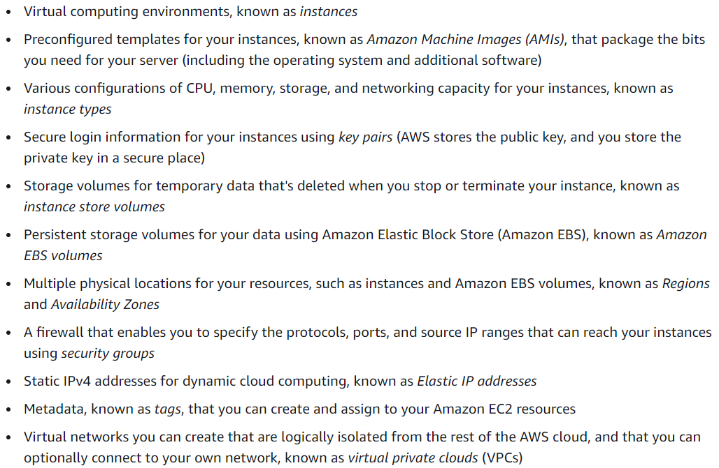

* EC2 is nothing but the virtual servers in cloud

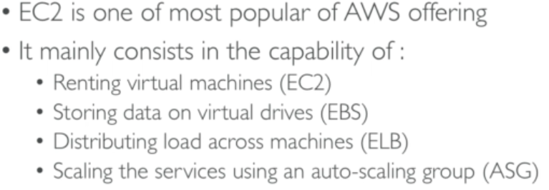

**Types:**

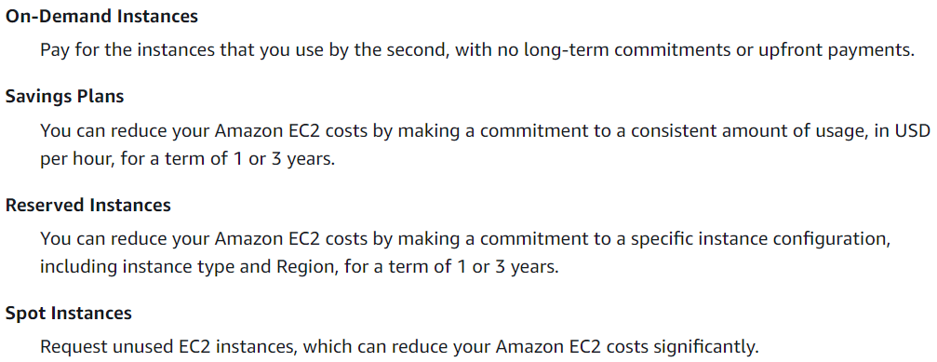

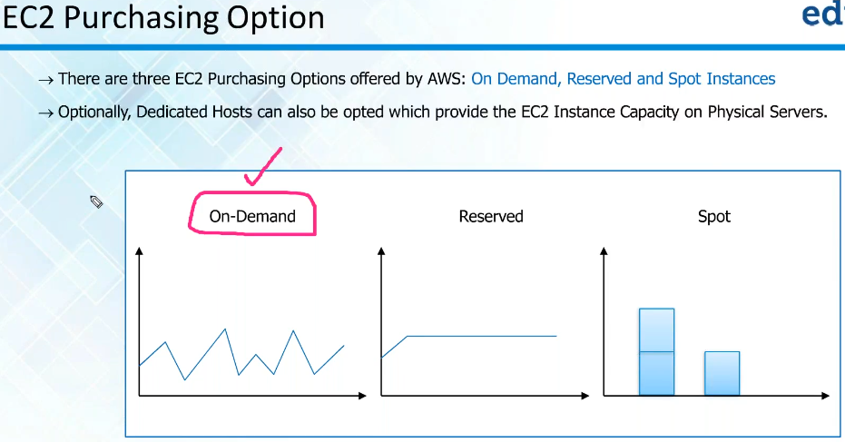

**OnDemand instances:**

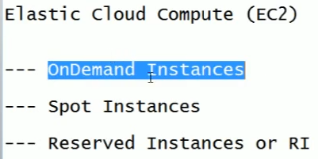

* In cloud, we use virtual CPU
* By default, any instance is called on demand instance
* When ever we are not sure about the capacity. We go for on demand instance
* The price is based on compute units per hour. It is hourly base charges



**Spot instances:**

* In order to decrease the price, they have gone to spot instance
* We can give a bit price by requesting spot instance and if once the price got decreased to the requested bit price. It automatically creates the instance
* We can also check the price history under spot instances

**Reserved instance:**

* Reserved instances are heavily used in production
* Dedicated hosts mean they will give us separate hardware

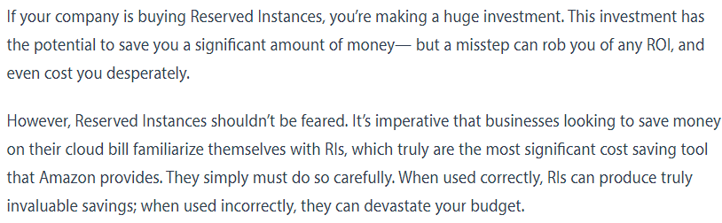

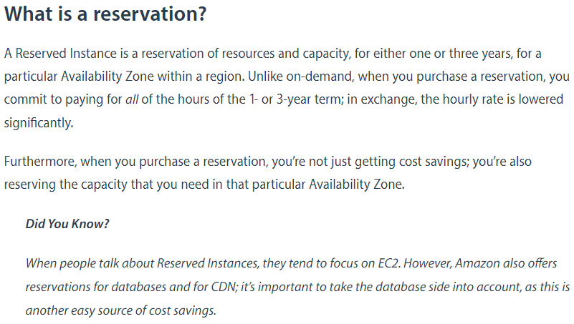

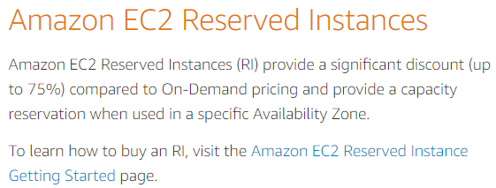

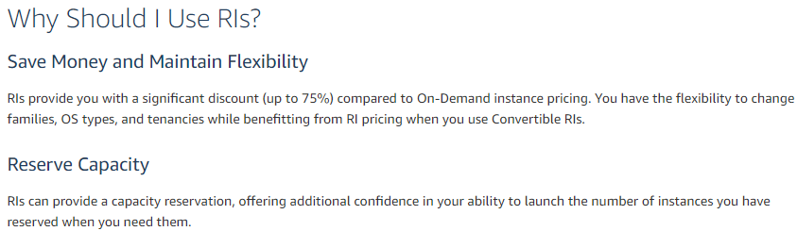

* When we want the server up and running all the time. Like web server, email server
* This kind of server we need to go for reserved instance. We will get discount as well
* We can also increase the size of reserved instances. But the charges will be there based on demand instance
* If we reduce it, we won’t get any refund
* This helps to run the instance as a web server
* Chkconfig always checks the apache server on even after reboot or something
* Html files stores in /var/www/html folder

**To change the instance type, we need to bounce stop the instance**